**PRACTICAL**

**Internet**

**Of**

**Things**

**(IoT)**

SHEKHAR SUMAN

CERTIFICATE

|  |  |  |
| --- | --- | --- |
| Class: **T.Y.B.Sc.I.T.** |  | Year: **2025 - 2026** |
|  |  |  |
| This is to certify that work entered in this Journal is the work of  Shri / ~~Kumari~~: SHEKHAR SUMAN .  of **T.Y.B.Sc.I.T** division Roll No. 47 .  Uni. Exam No. . has satisfactorily completed the  Required number of practical and worked for the  **5th** Semester  Of the year 2025 - 2026 in the college laboratory as laid down  By the university. | | |

|  |  |  |
| --- | --- | --- |
| Head of the | External | Internal Examiner |
| Department | Examiner | Subject teacher |

Date:

|  |  |  |
| --- | --- | --- |
| **NAME**: **SHEKHAR SUMAN** |  | **INDEX** |
| **CLASS**: T**.Y.B.Sc.I.T.** | **ROLL** **No**: **47** |
| **SUBJECT**: **INTERNET OF THINGS (IoT)** |  |
| **COLLEGE:** **ST. ROCK’S DEGREE COLLEGE** | |

|  |  |  |
| --- | --- | --- |
| **PR No:** | **TITLE** | **SIGN** |
| **1** | Understanding Raspberry Pi and its pins. |  |
| **2** | Installing operating system NOOBS on SD card and burning it. |  |
| **3A** | Installing Raspbian OS on raspberry Pi. |  |
| **3B** | Installing Raspbian OS with the help of virtual machine software. |  |
| **4** | Blinking LED using Raspberry Pi. |  |
| **5** | Capturing Images by connecting camera using Raspberry Pi. |  |
| **6** | Capturing video by connecting camera using Raspberry Pi. |  |
| **7** | Interfacing seven segment display with Raspberry Pi. |  |
|  |  |  |
|  |  |  |
|  |  |  |
|  |  |  |

PRACTICAL – 1

AIM: Understanding Raspberry Pi and its pins.  
  
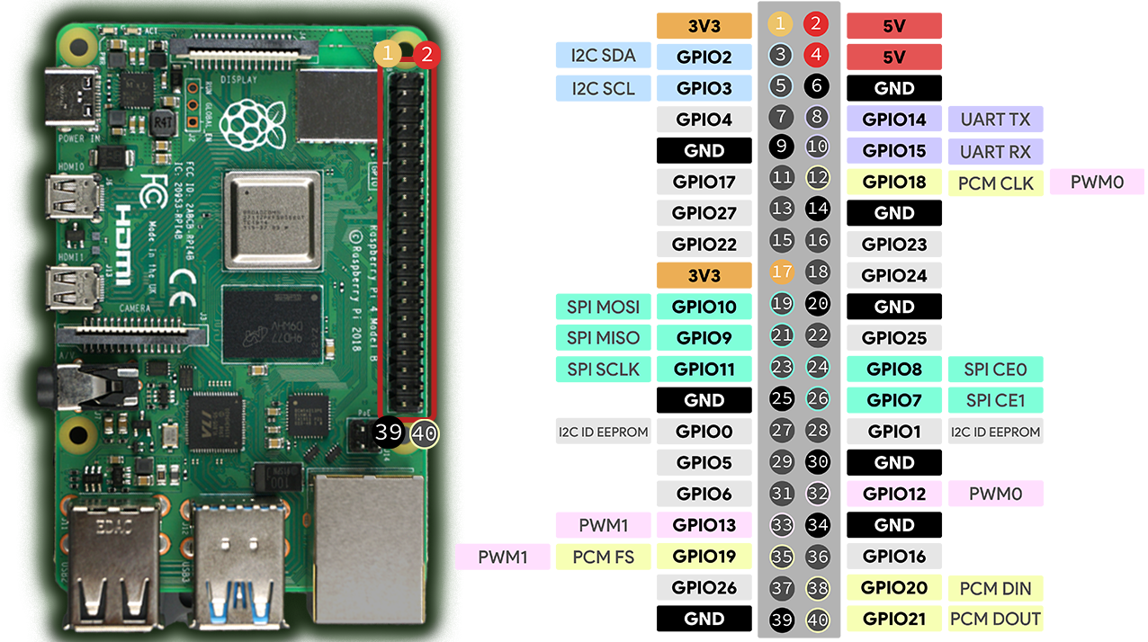

**Raspberry Pi GPIO Pins Overview**

* **Physical Pins:** The header on the Raspberry Pi consists of 40 pins, numbered from 1 to 40 (top left to bottom right in the image).
* **Types of Pins:**
  + **Power Pins:**
    - 3.3V (Pins 1, 17): Orange blocks.
    - 5V (Pins 2, 4): Red blocks.
    - Ground/GND (Pins 6, 9, 14, 20, 25, 30, 34, 39): Black blocks.
  + **GPIO Pins:** Used for input/output operations. Named GPIO followed by a number (e.g., GPIO2, GPIO3).
  + **Special Function Pins:**
    - **I2C:** Pins for communication using Inter-Integrated Circuit protocol (Pins 3 (SDA), 5 (SCL), light blue).
    - **UART:** Pins for serial communication (Pins 8 (TX), 10 (RX), purple).
    - **SPI:** Pins for Serial Peripheral Interface (MOSI, MISO, SCLK, CE0, CE1; green blocks).
    - **PWM:** Pins for Pulse Width Modulation (PWM0, PWM1; light purple).

**How to Use These Pins**

* **Digital Input/Output:** Most pins labeled GPIO can be programmed to read digital sensors (input) or control devices like LEDs (output).
* **Communication Protocols:** Use the I2C, SPI, and UART specific pins to connect with modules that support these protocols.
* **Power Supply:** Use the 3.3V or 5V pins and GND pins to supply power to your connected components.

**Example Practical: Blink an LED**

1. **Connect:**
   * LED’s positive leg to GPIO17 (Pin 11).
   * LED’s negative leg to GND (Pin 6).
2. **Write a Simple Python Code:** Use GPIO17 in your code to turn the LED on/off.

**Summary Table (Main Functions)**

| **Pin No.** | **Function** | **Color Code** |
| --- | --- | --- |
| 1, 17 | 3.3V Power | Orange |
| 2, 4 | 5V Power | Red |
| 6, 9... | Ground (GND) | Black |
| 3, 5 | I2C SDA/SCL | Light Blue |
| 8, 10 | UART TX/RX | Purple |
| 19, 21, 23, 24 | SPI (MOSI, MISO, SCLK...) | Green |
| 11, 13, ... | GPIO Pins | Blue, Yellow |

**PRACTICAL – 2**

**aim:** Installing operating system NOOBS on SD card and burning it.

Downloading the **SD CARD** formatter.

**Step 1:** Browse the SD card formatter download in your browser and go with the original link.

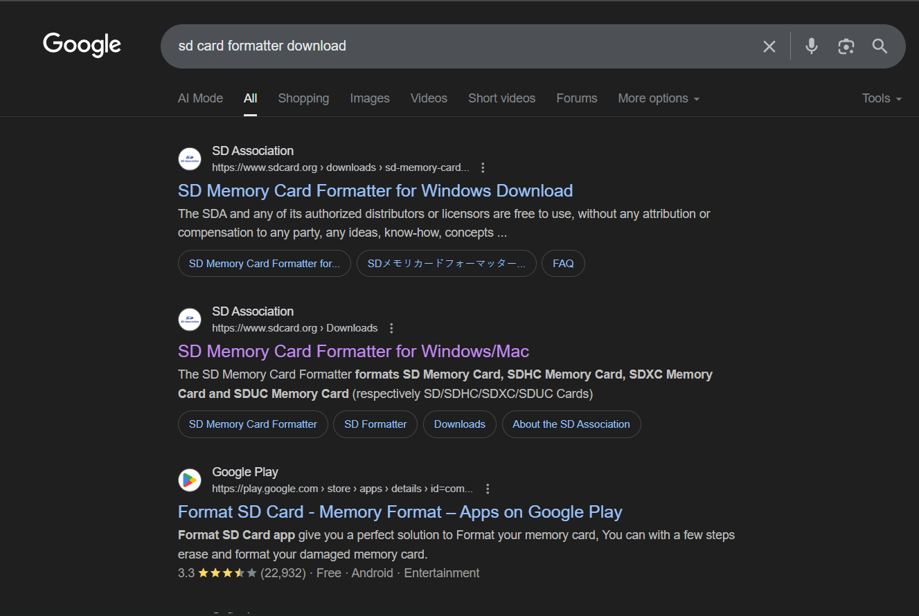

Go with this link

**Step 2:** After that scroll down and find this option then choose your operating system, here my operating system is Window so I prefer myself to choose Window option.

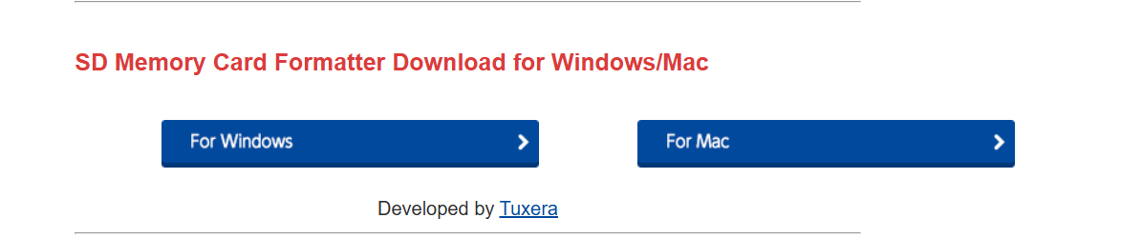

**Step 3:** On the clicking on Window option, you got the interface of SD card formatter user license and agreement with their notice. Read carefully and scroll down and find this option then click on Accept button. When you click on the Accept button then your file is automatically downloading in the ZIP format.

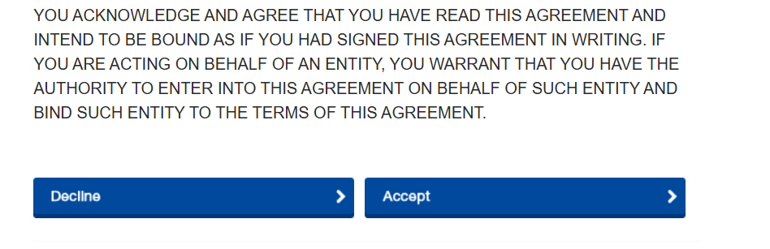

**Step 4:** Once your download is complete then open your file explore and go to the download option find your downloaded file and extract that file.

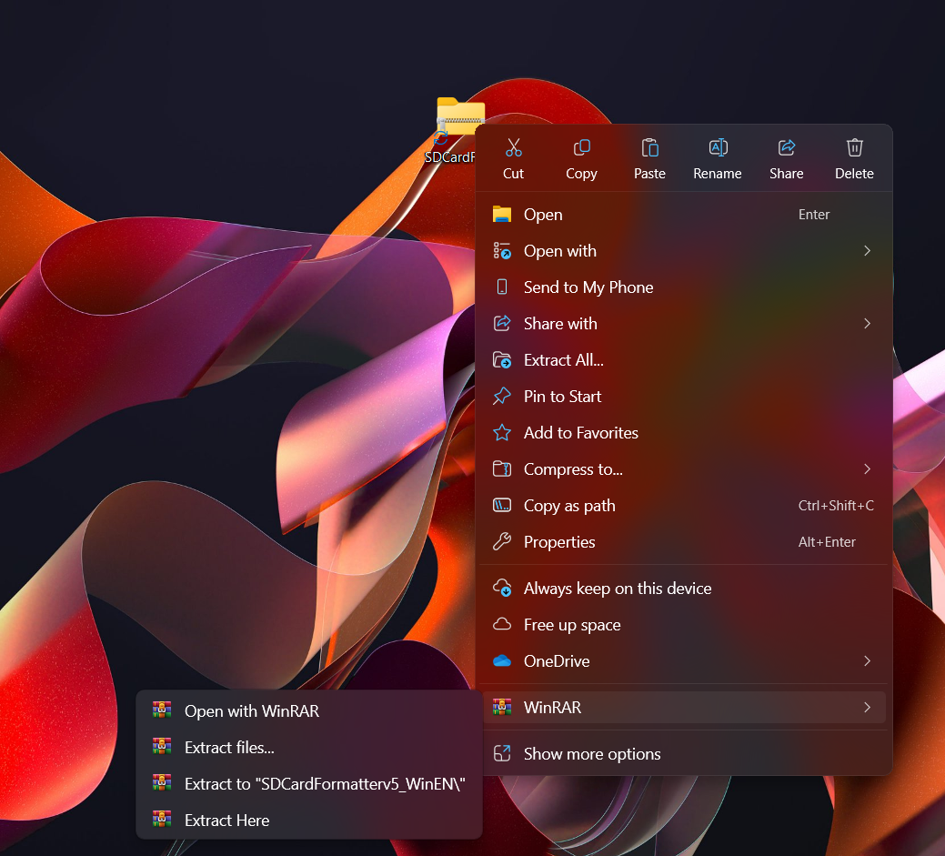

**Step 1: Choose WinRAR, Then Extract Here Option**

**Step 5:** When your extraction is complete then you got the new folder with the same name where you extract your folder. Go inside that folder you find the application file.

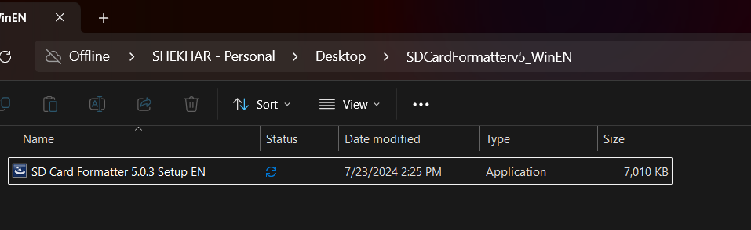

**Step 6:** Double click on it, it takes few seconds for the preparing your installation. Once your preparing is done then you got the interface of InstallShield Wizard, click on the next button for the next processing.

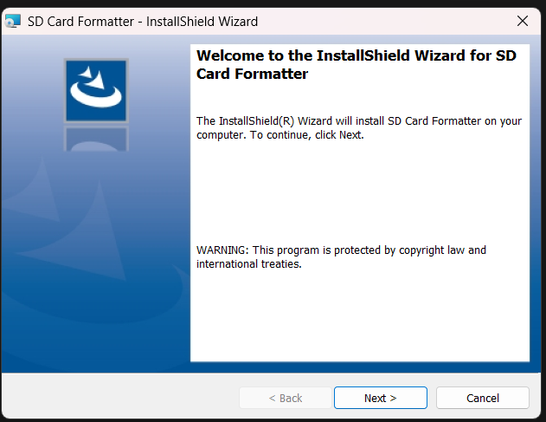

**Step 7:** Accept the terms and license agreement then click on the next button.

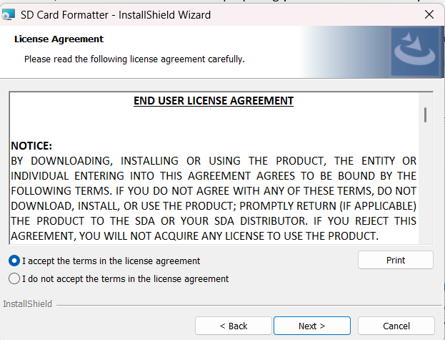

**Step 8:** Then it asks from you for the application destination, if you want to change your location / destination the browser your destination, here I don’t need to change my destination so I go with the default location. Then I click on the next button.

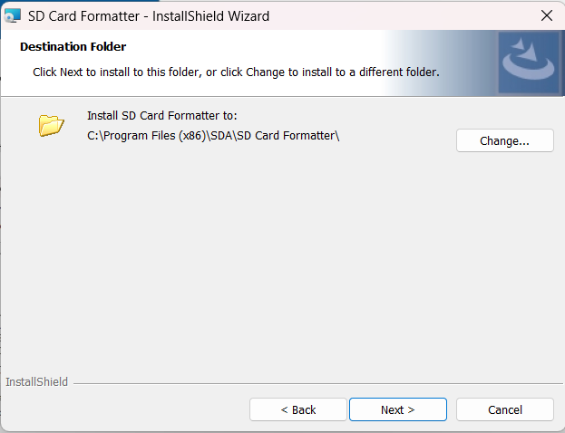

**Step 9:** Then your application is ready to install, you can see your information about this application click on the install button for the installing your application. When your click on the install button it takes some times for preparing your installation. Once your installation is done then click on the finish button here your SD card formatter in successfully download.

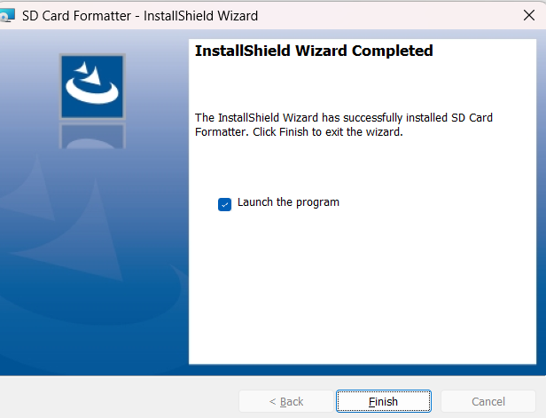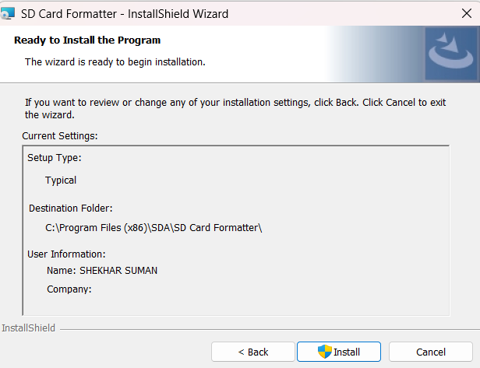

**Step 10:** Insert your SD card in your laptop / computer with the help of card reader then open the SD card formatter application it automatically detects your SD card. They’re you can see your card information and formatting options. In formatting options, you have to choose Quick format, below the formatting options you can see the Volume label here you can give the name of your SD card whatever you want here I give my name “SHEKHAR SUMAN”, at first time it detects automatically according to your SD card name. after this process click on the format button.

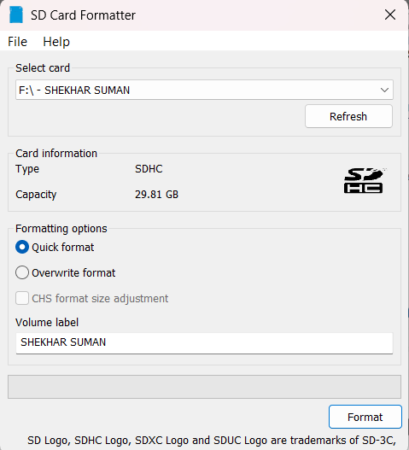

**Step 11:** Once your format is done then you see the interface of formatting was successfully completed.

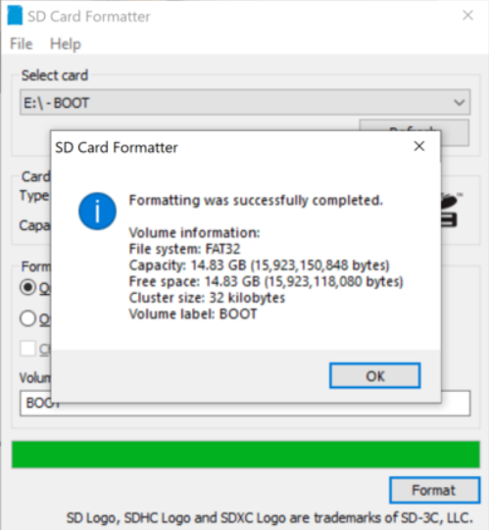

**O.S Manager NOOBS Installation**

**Step 1:** Browse in the browser Raspberry pi download go with the first link

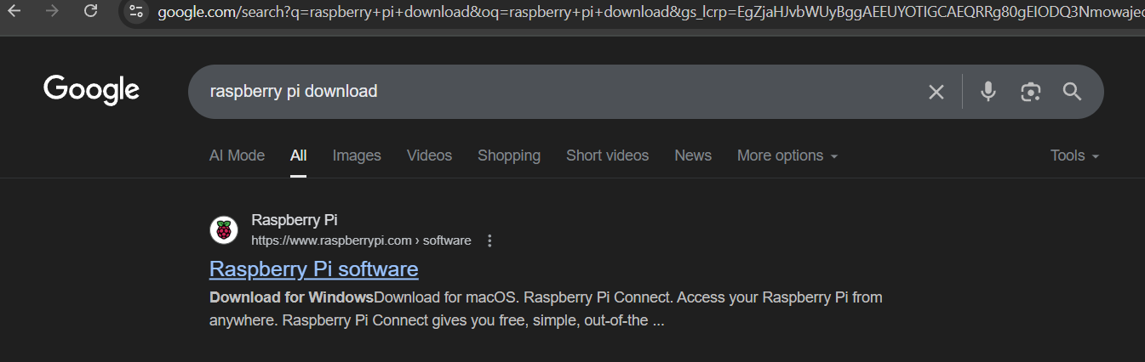

**Step 2:** Here we can see that raspberry pi software Raspberry pi Imager, then choose your Operating system. When you click on the Download for according to your operating system, then your exe file is start downloading.

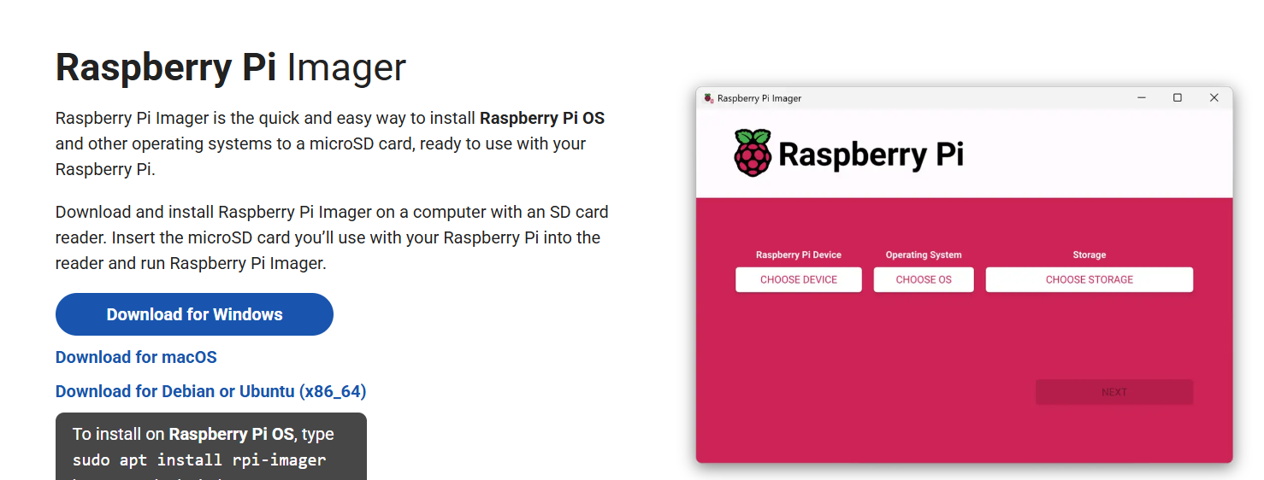

**Step 3:** After the downloaded of exe file then double click on that file and open it, then its ask from you choose your language then press on the ok button.

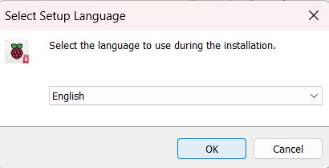

**Step 4:** Then you redirect on the set-up page on your raspberry imager click on the next button.

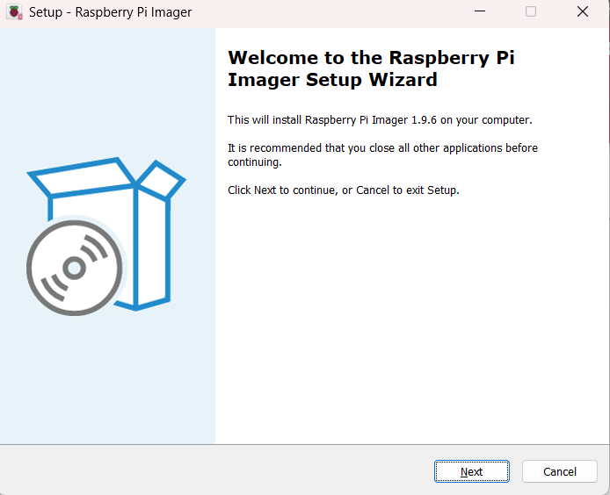

**Step 5:** Accept the agreement after that then click on the next button.

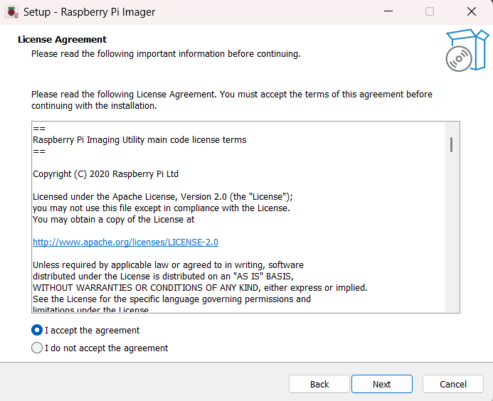

**Step 6:** Choose the destination location if you want otherwise make it default. Then click on the next button.

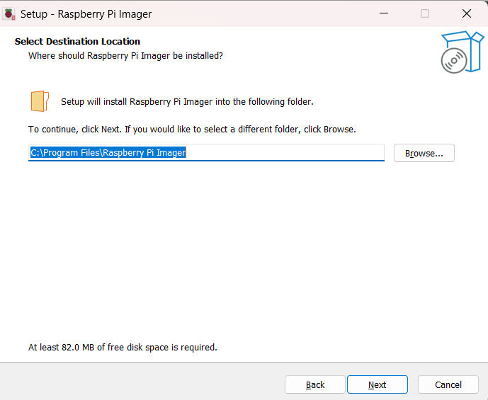

**Step 7:** Then you got the option for creating desktop shortcuts if you want then check on the checkbox otherwise make it unchecked and click on the next button.

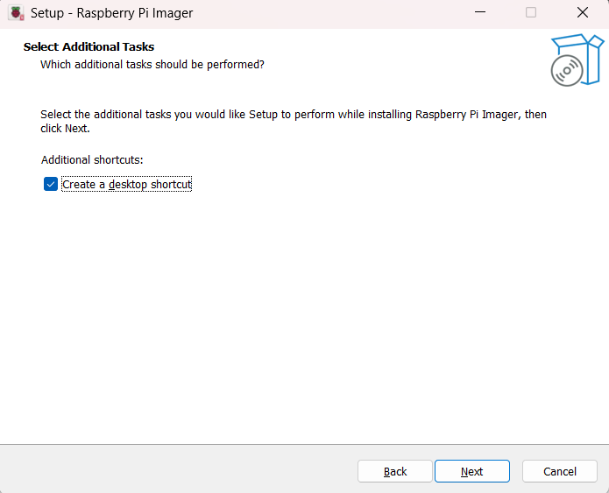

**Step 8:** It is installing now when it successfully installed on your computer then you got, he completing the Raspberry pi imager set-up wizard. Then you have the click finish button to exit the setup.

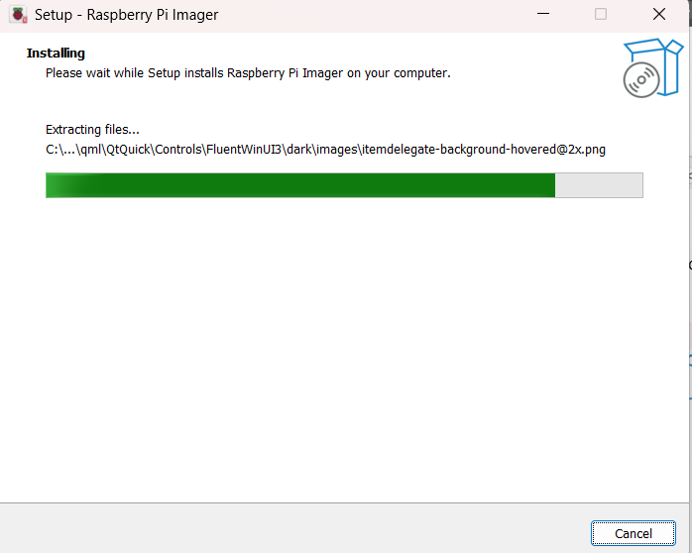

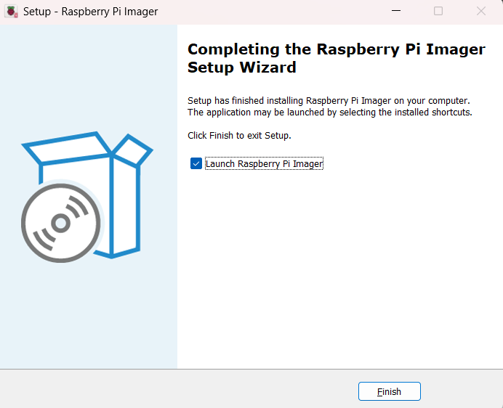

**The final output of installation is this, this is the interface of the Raspberry Pi imager Application.**

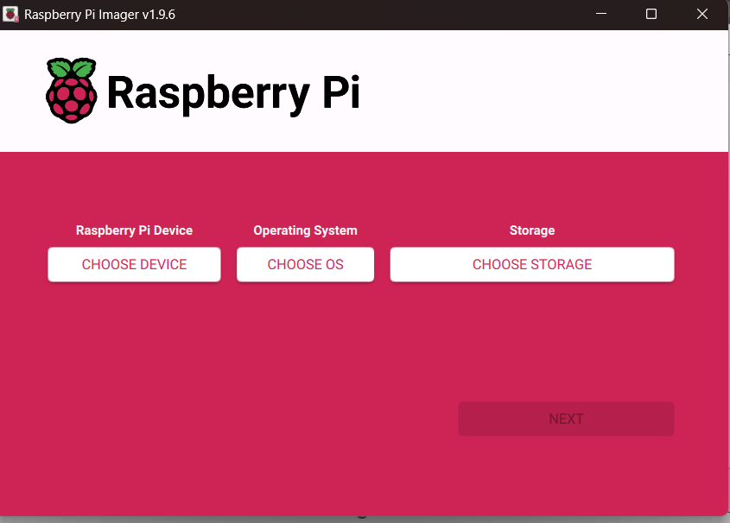

**PRACTICAL 3A**

**AIM:** Installing Raspbian OS on raspberry PI

|  |  |  |
| --- | --- | --- |
| **SR.No.** | **REQUIREMENTS** | **WORKS** |
| 1 | Raspberry Pi | The main mini-computer where the OS runs. |
| 2 | SD card | Works as the storage drive to hold Raspberry Pi OS and files. |
| 3 | HDMI cable | Connects Raspberry Pi to a monitor/TV for display output. |
| 4 | Montier | Displays the Raspberry Pi OS interface. |
| 5 | Adaptor | Supplies stable power to the Raspberry Pi. |
| 6 | USB Type C cable | Provides power supply to the Raspberry Pi. |
| 7 | Key Board & Mouse | Used for input and controlling the Raspberry Pi. |

**About the Raspberry Pi.**

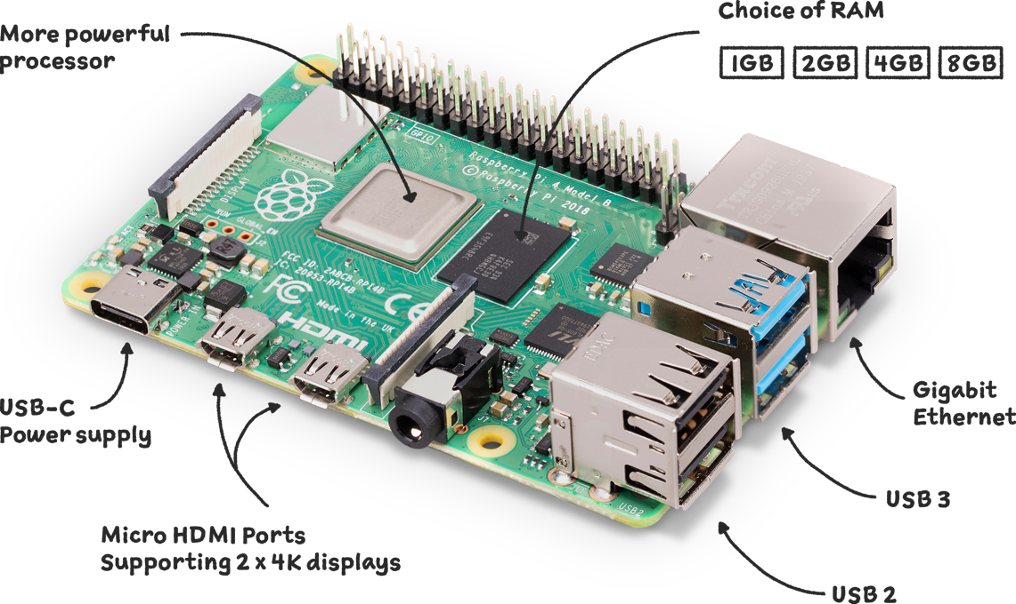

**CONNECTION**

**Step 1:** Insert the SD card into the Raspberry Pi, it acts as the main storage, containing the Raspberry Pi OS, and allows the system to boot and run applications properly.

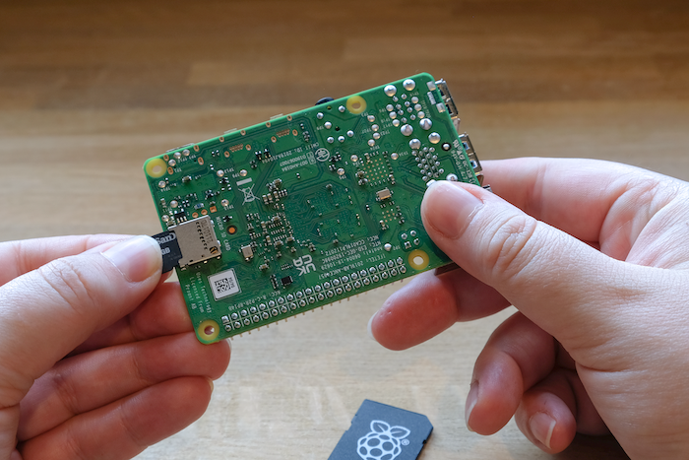

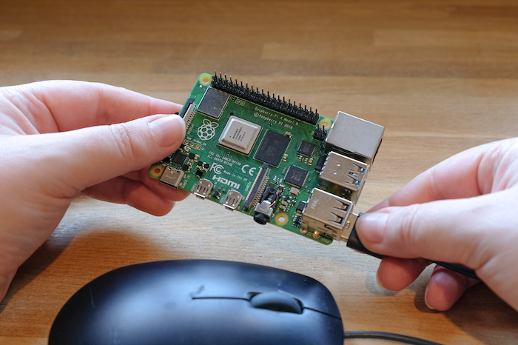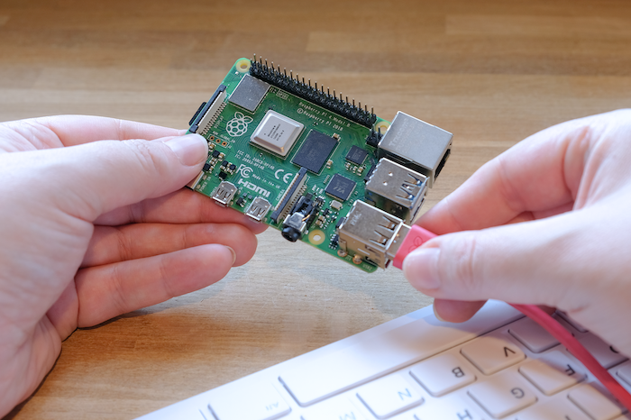**Step 2:** Connect the keyboard and mouse to the Raspberry Pi, they provide input control, allowing us to type commands, navigate the desktop, configure settings, and interact with the operating system easily.

**Step 3:** Connect the HDMI cable to the Raspberry Pi, it transfers both video and audio signals, enabling the monitor or TV to display the operating system and user interface clearly.

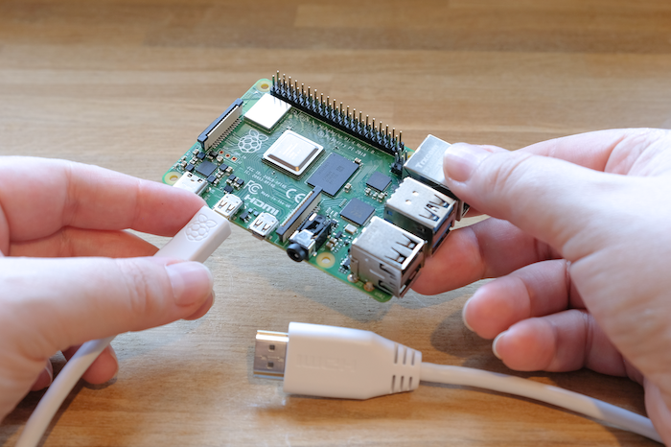

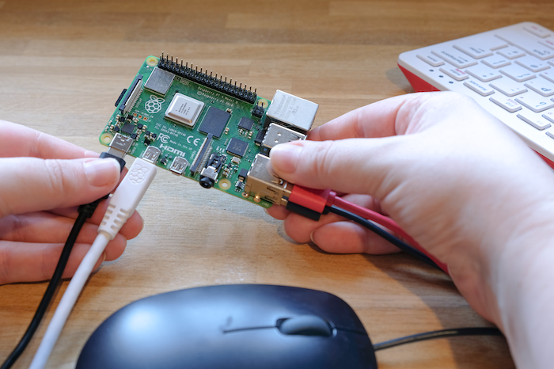**Step 4:** Connect the Type-C cable to the Raspberry Pi, it provides the required power supply, ensuring the board starts, runs the operating system, and functions properly for all tasks.

When all connections are done and we power the Raspberry Pi:

1. **Red LED lights up** → confirms power supply.
2. **Green LED blinks** → Raspberry Pi reads the SD card and boots the OS.
3. **Display appears on monitor via HDMI** → Raspberry Pi OS logo and boot process show up.
4. **Keyboard and mouse become active** → allow you to control and set up the system.
5. **Raspberry Pi is ready to use** → you can start programming, browsing, or running projects.

**CONNECTION DIAGRAM**

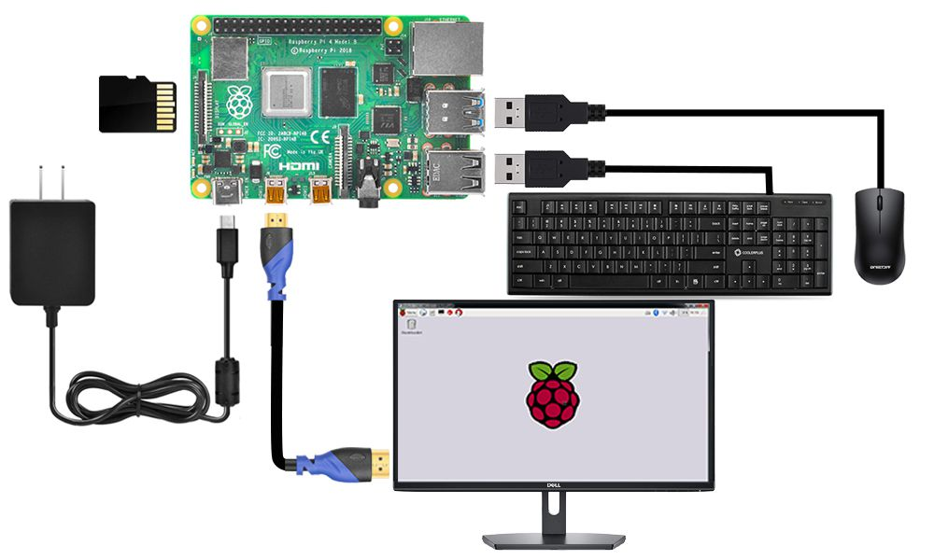

**INSTALLATION**

In the beginning it shows the error of the internet connection like this.

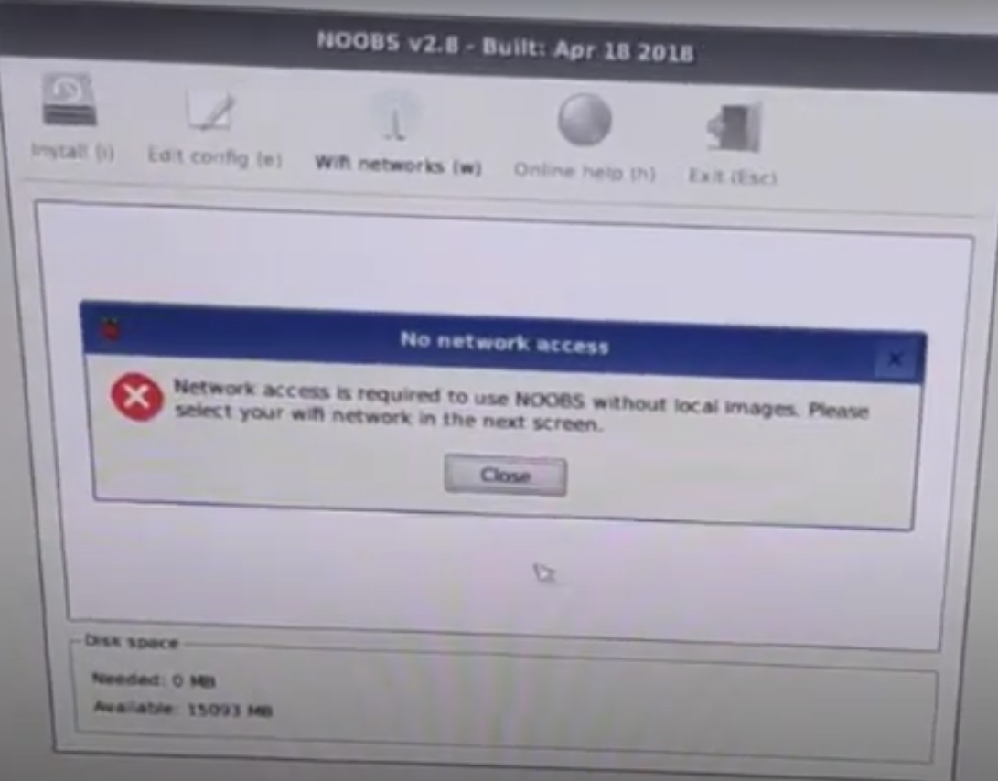

**Step 1:** Select your Wi-Fi name, after the selection of your Wi-Fi name then enter the password and hit the ok button.

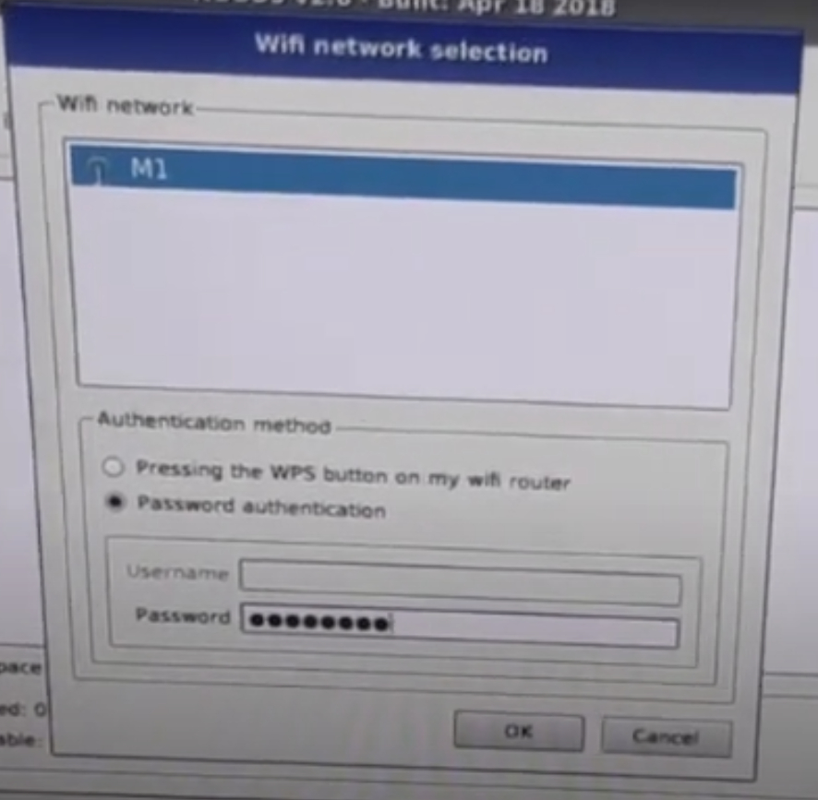

**Step 2:** Select your preferred operating system from the NOOBS menu, then click “Install.” The Raspberry Pi will automatically install it.

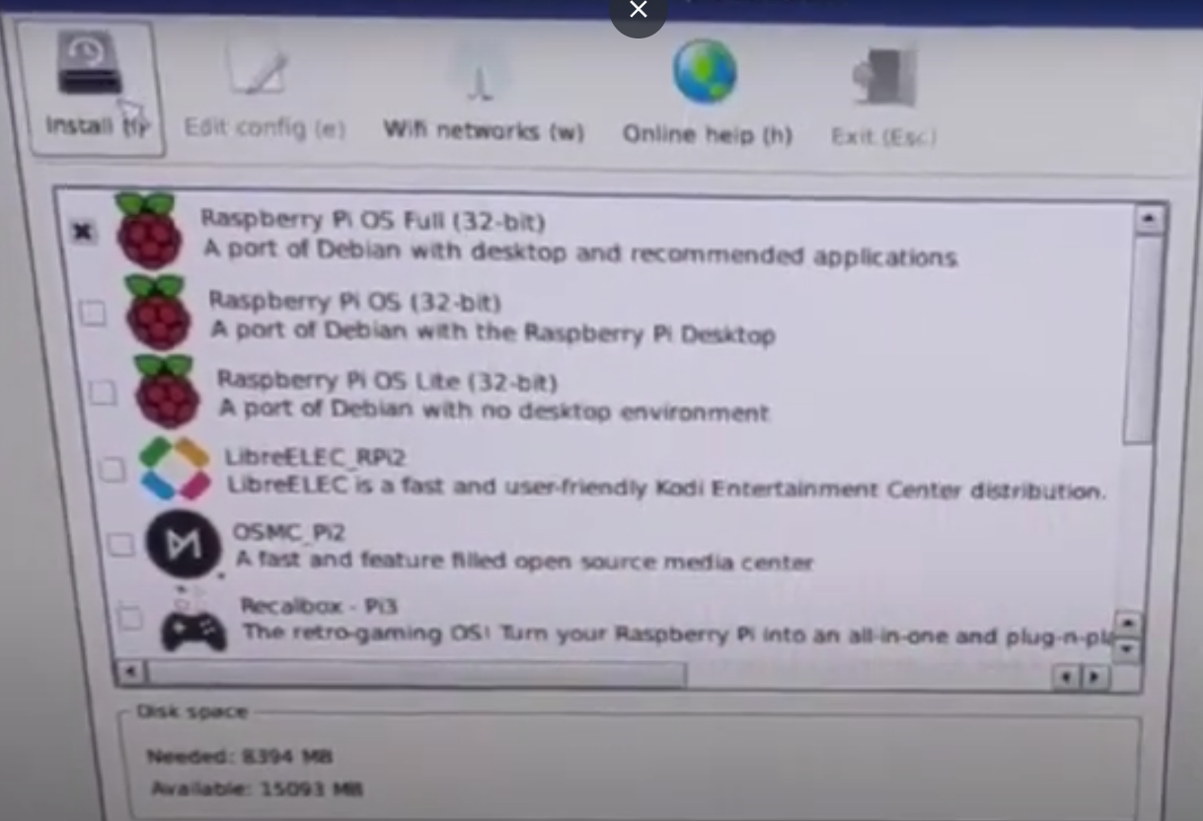

**Step 3:** After clicking on the install button, it shows a warning click on the Yes button.

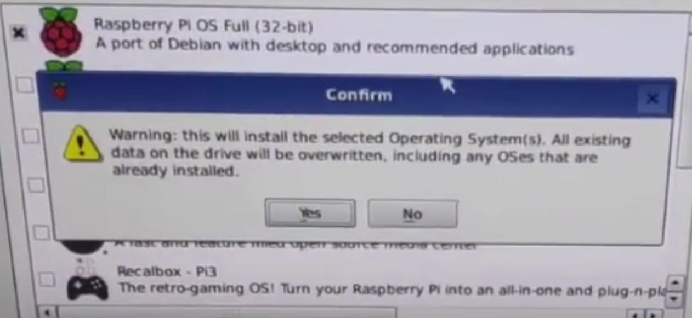

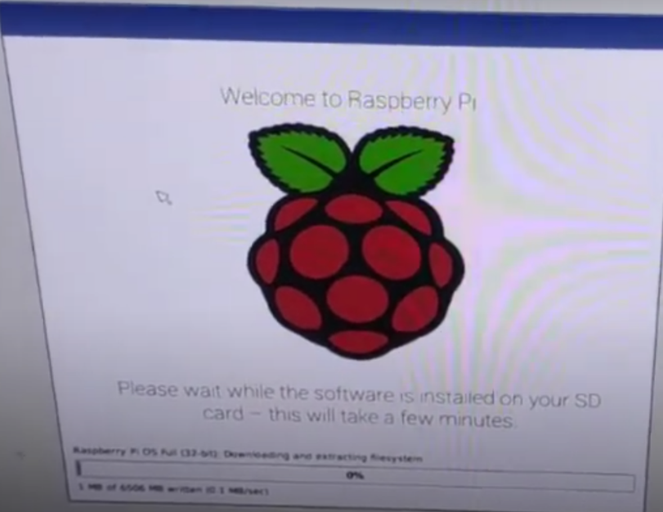**Step 4:** Now it is Installing.

**Step 5:** When this is installed then you show the Installed successfully message, then click on OK button.

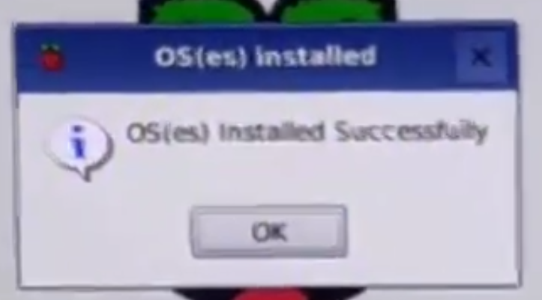

**Step 6:** After the successfully installation then we have to do some set-up, Now you see the set-up dialog click on the Next button.

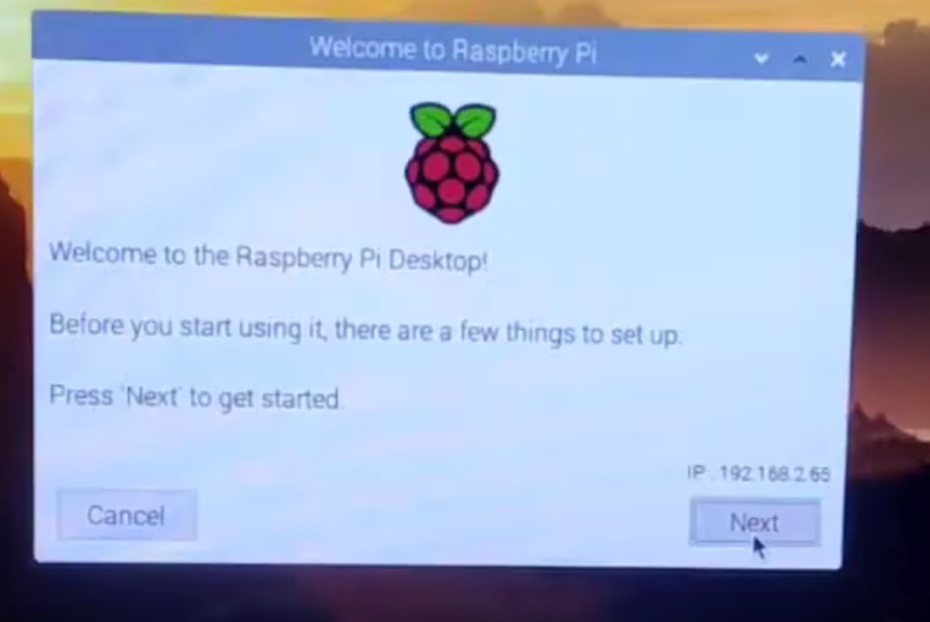

**Step 7:** Then click on the checkbox of Use English Language and Use US Keyboard

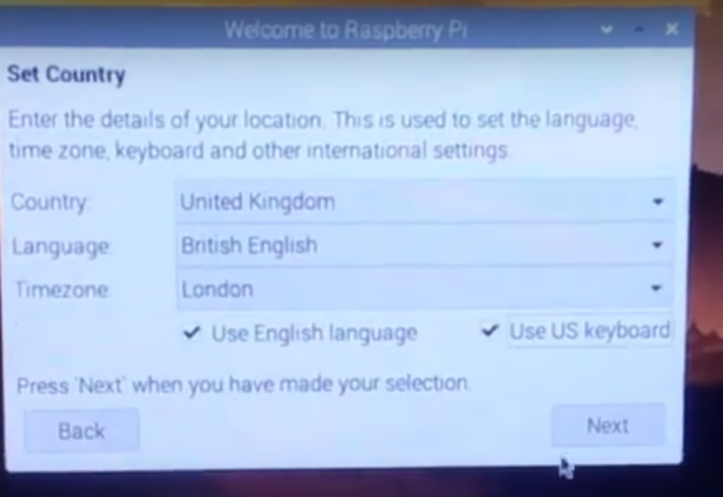

**Step 8:** After clicking the next button then we show the change password interface, here no need to keep password, if you want then you can choose randomly otherwise the default password is “raspberry”. Then click on the next button.

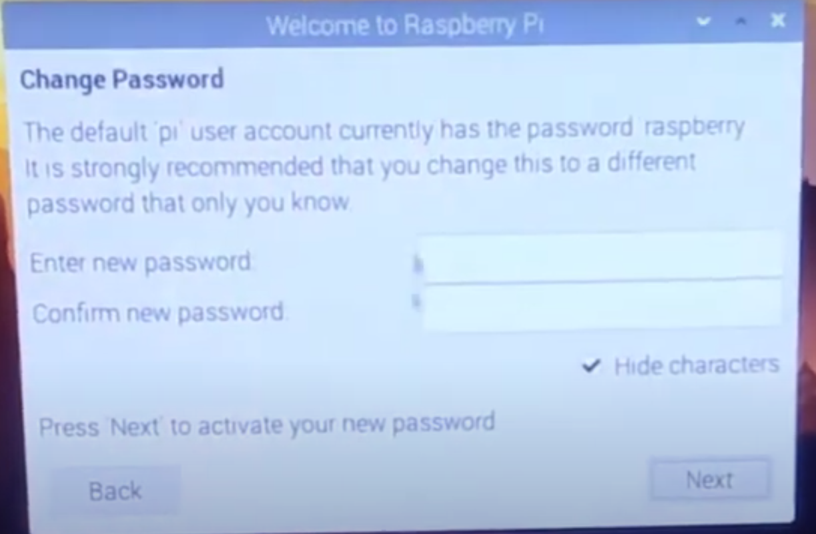

**Step 9:** Now we show the Setup screen interface, here nothing to do changes then click on the next button.

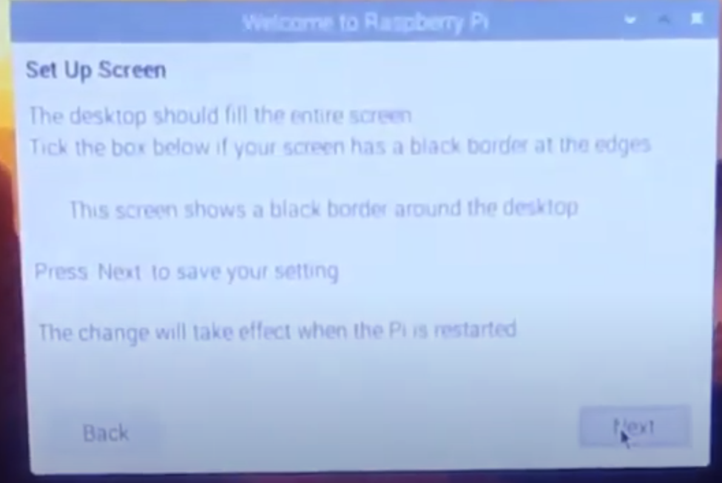

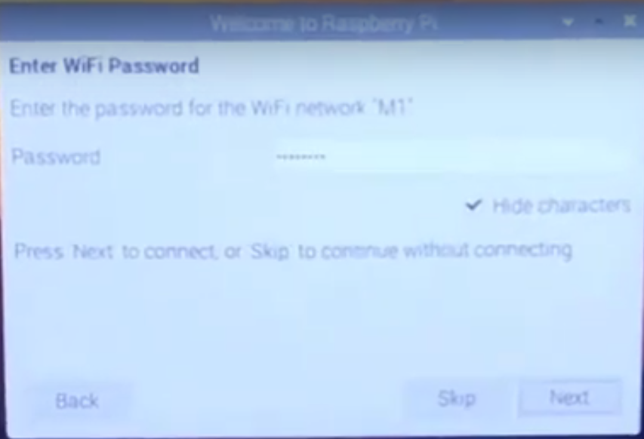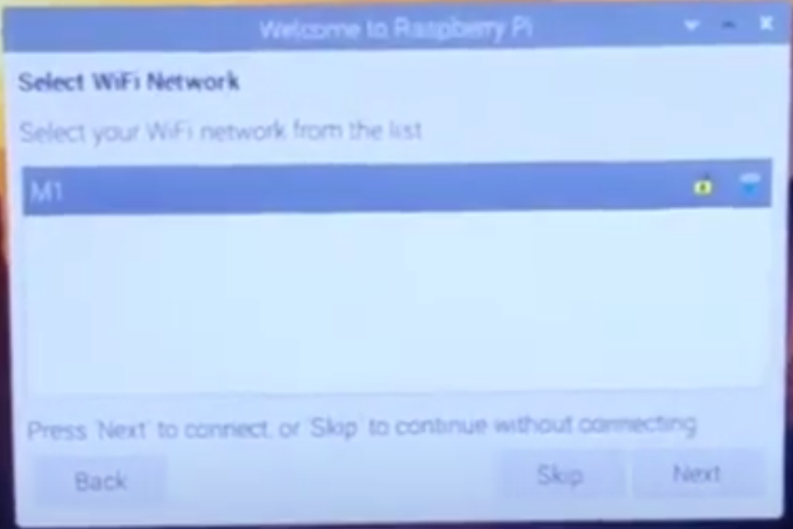**Step 10:** Select your Wi-Fi and select Next button then Enter your Wi-Fi password again click on the Next button.

**Step 11:** Now you see the Update software at this time we don’t need to update it takes so many times to update, so we click here **Skip.**

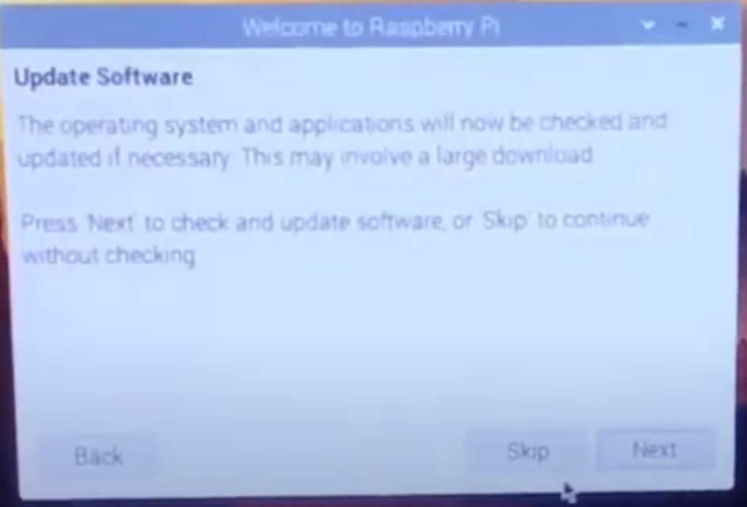

**Step 12:** Now we have the interface of Setup Complete and click on the Done button.

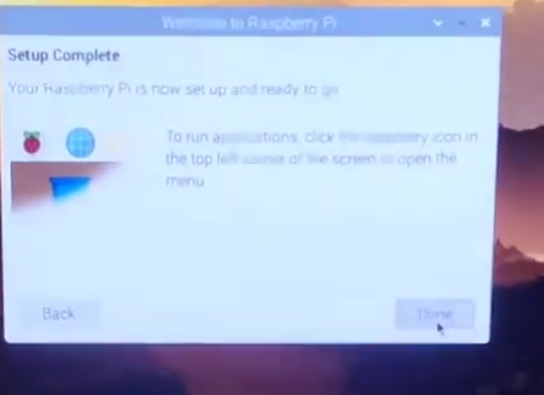

**Step 13:** Now we are good to go to run our raspberry pi. Here is the final Output of the raspberry pi display.

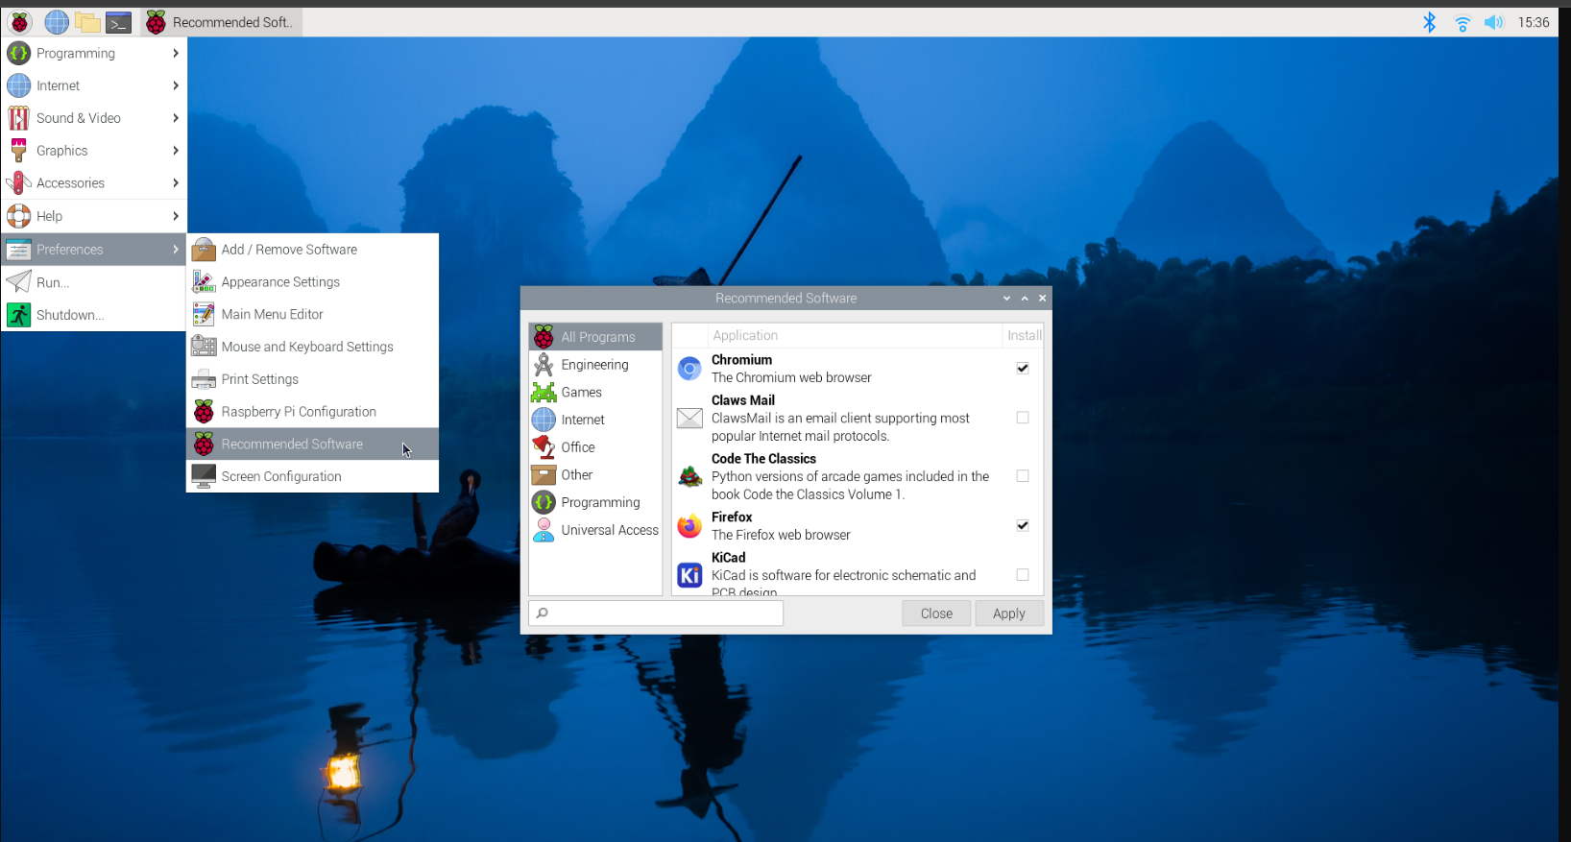

**PRACTICAL – 3B**

**AIM:**  Installing Raspbian OS with the help of virtual Machine software.

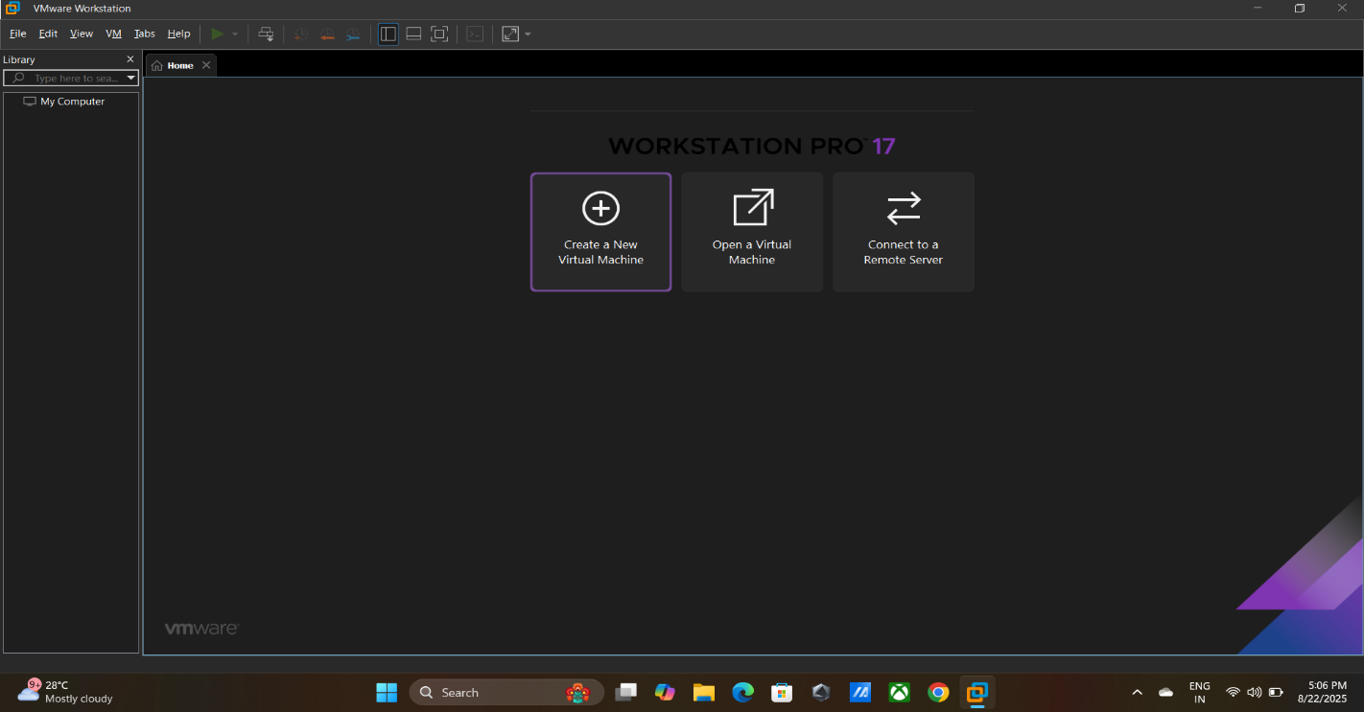**Step 1:** Open VMware and click on create new virtual machine

**Step 2:** Now click on Typical and click on the Next button.

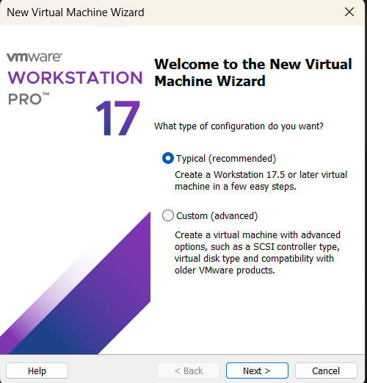

**Step 3:** Then browse the **ISO** file and again hit the next button.

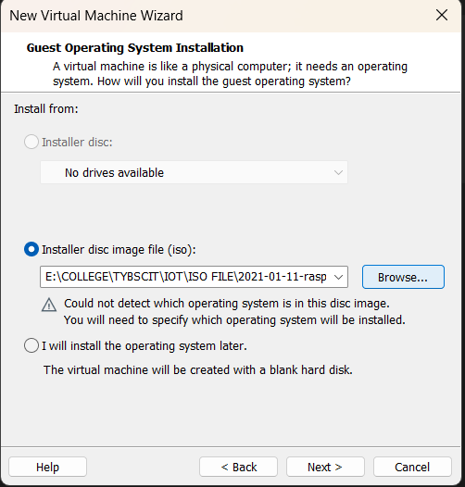

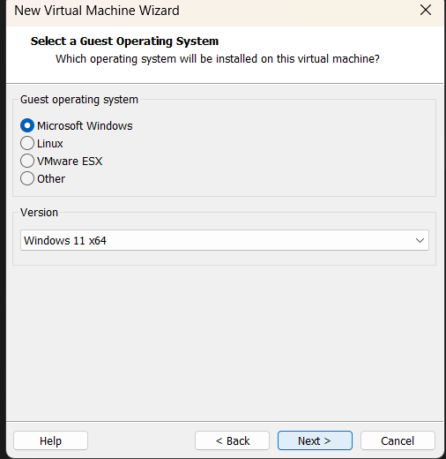**Step 4:** Click on the Microsoft window and click on the Next button.

**Step 5:** Now the system asks the name of our virtual machine, here I don’t want to change the name so I go with the default name then click on the next button.

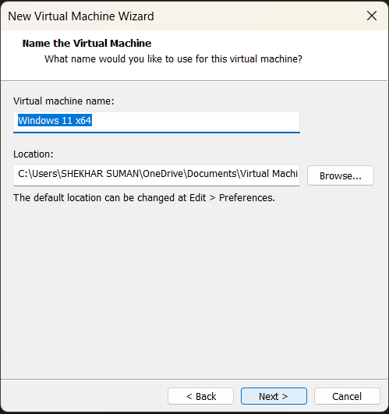

**Step 6:** Then create your strong password then click on the next button.

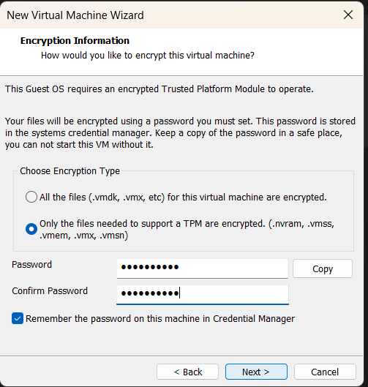

**Step 7**: Nothing to change here and click on the next button.

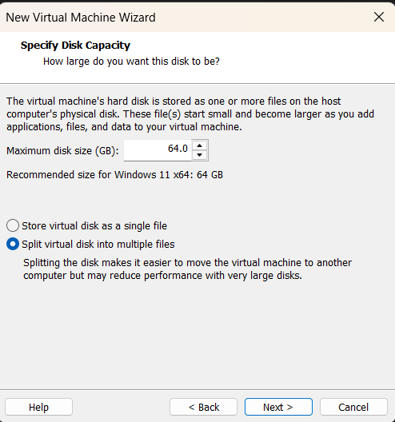

**Step 8:** Then click on the finish button to finish of the setup Raspbian **ISO** file.

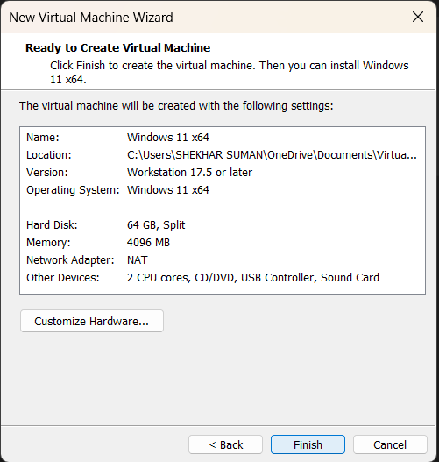

**Step 9:** Now we automatically redirect on the home interface of the VMware application. Select your machine name and click on the power on this virtual machine. This option is at top left hand side.

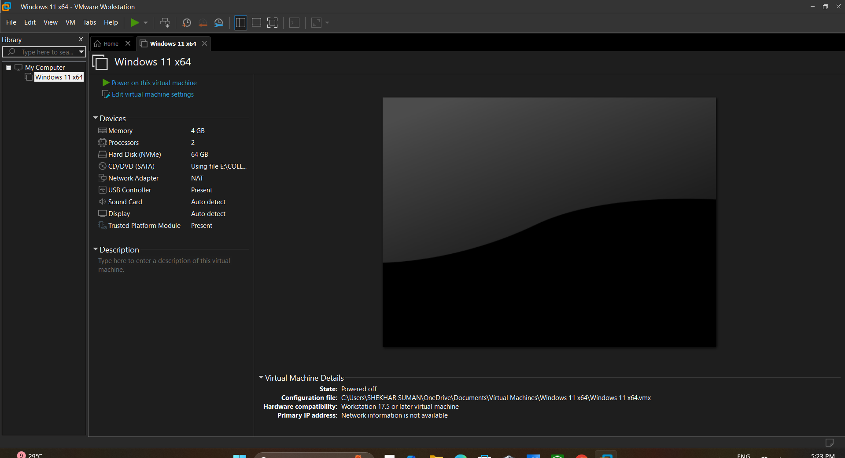

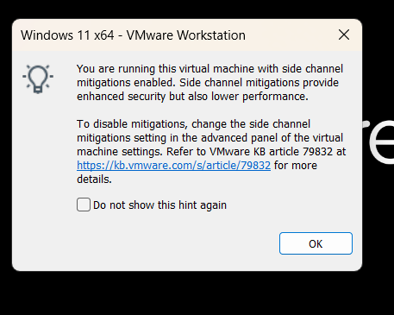**Step 10:** Now here we show the unwanted option interface click on the OK button for the Next.

**Step 11:** Now we redirect to the Set-up the Raspbian O.S on the VMware software. Click on the next button.

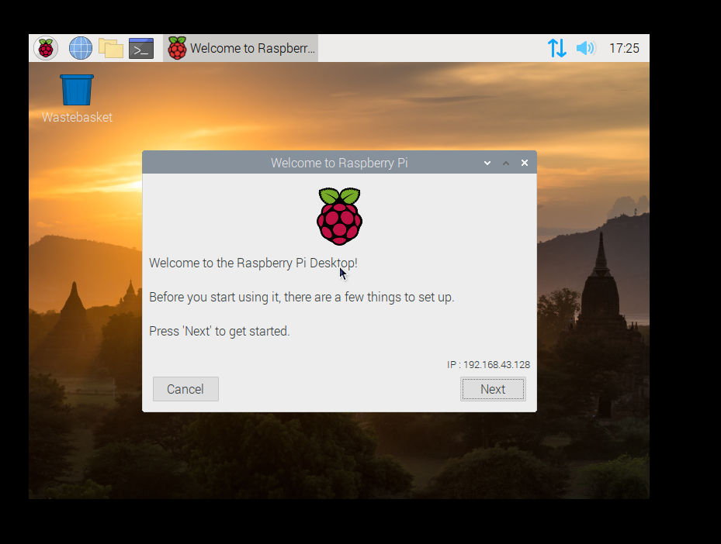

**Step 12:** After clicking on the Next button then click on the both option Use English language and Use U.S keyboard then click on the Next Button.

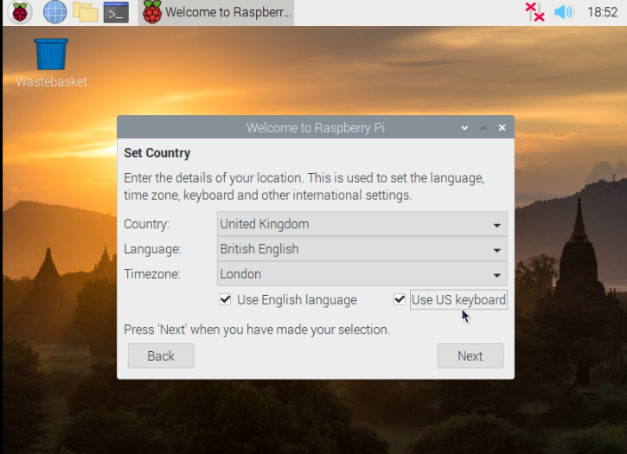

**Step 13:** I don’t want password here so I kept it blanks, if you want your personal password then you can enter the password otherwise, they have their own default password “raspberry”. Then click on the Next button.

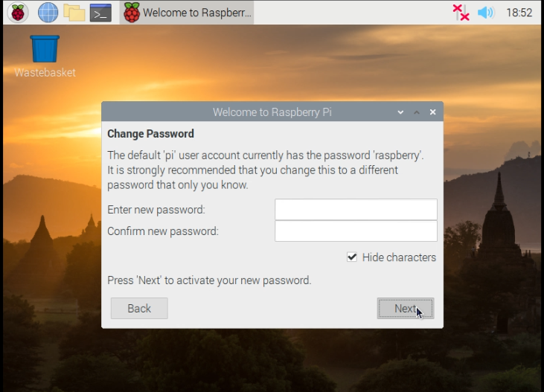

**Step 14:** I don’t want any update right now then I want to choose skip button for the skip the Updates.

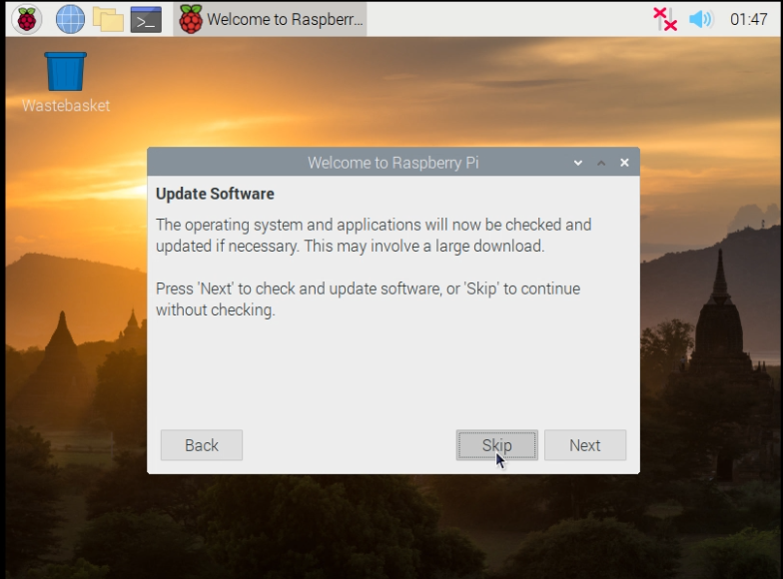

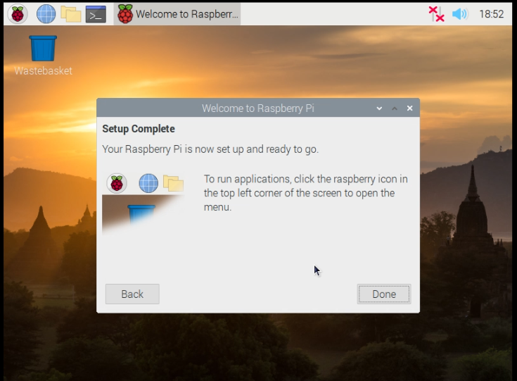**Step 15:** This is the last and the final process of yours installing the Raspbian O.S on your VMware box. Now you get the interface of Setup complete. Click on done button and Enjoy your Raspbian O.S on your VMware box.

**The final desktop of Raspbian O.S in the VMware workstation.**

**PRACTICAL – 4**

**AIM:**  Blinking LED using Raspberry Pi.

**Step 1:** Connect LED to breadboard.

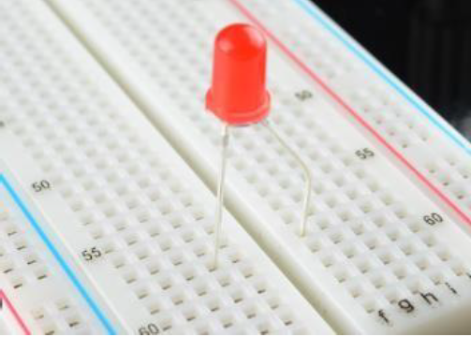

**Step 2:** Connect Resistor on breadboard.

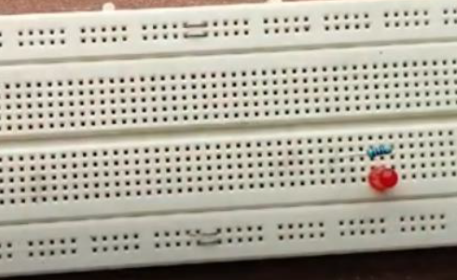

**Step 3:** Connect two jumper wire to breadboard of one leg is in register and another is in LED

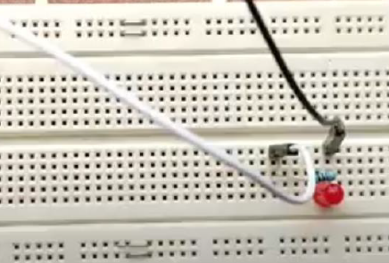

**Step 4:** Connect these jumper wire to Pin 7 and Pin 9 of Raspberry Pi respectively.

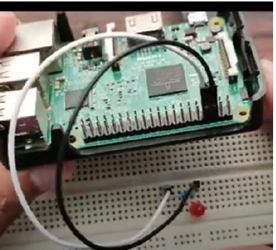

**Step 5:** Open Thonny Python IDE on Raspberry Pi OS.

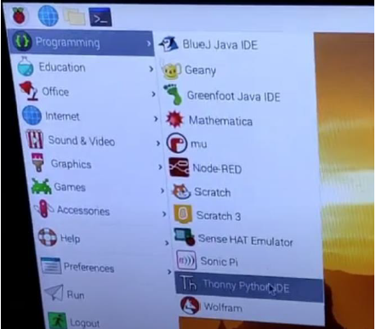

**Step 6:** Write a code on IDE to blink the LED and Run the code.

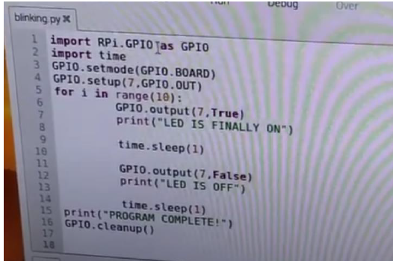

**PRACTICAL – 5**

**AIM:**  Capturing Images by connecting camera using Raspberry Pi.

**Step 1:** Insert Camera strip into CSI connector and power on the Raspberry Pi.

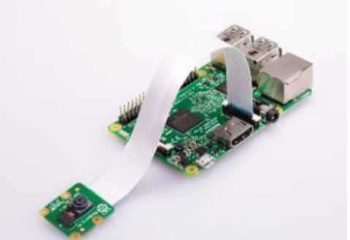

**Step 2:** Install Pip 3 on IDE.

**Step 3:** Install “Picamera” library on it

Syntax: - pip3 install picamera

**Step 4:** Write the Following code Thonny IDE and run the code.

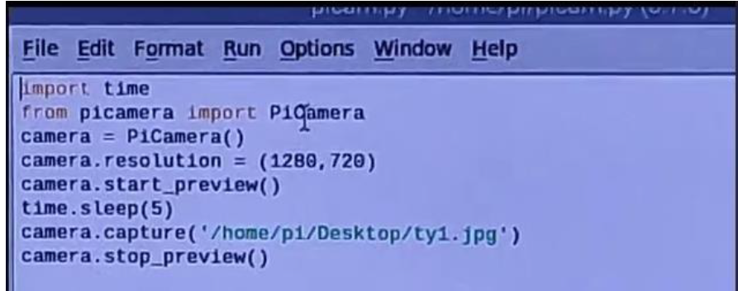

**PRACTICAL – 6**

**AIM:**  Capturing Images by connecting camera using Raspberry Pi.

**Step 1:** Insert Camera strip into CSI connector and power on the Raspberry Pi.

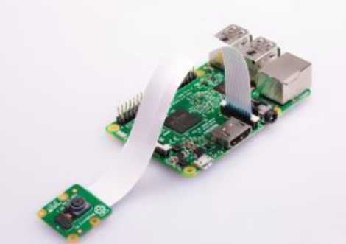

**Step 2:** Install Pip 3 on IDE

Syntax: - sudo apt-get install python3-pip

**Step 3:** Install “Picamera” library on it

Syntax: - pip3 install picamera

**Step 4:** Write the Following code Thonny IDE and run the code.

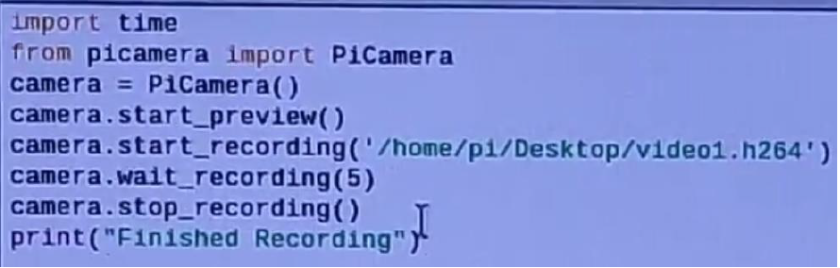

**PRACTICAL – 7**

**AIM:** Interfacing seven segment display with Raspberry Pi.

**Step1:** Connect 4 jumper wires to 4 digit 7-segment display.

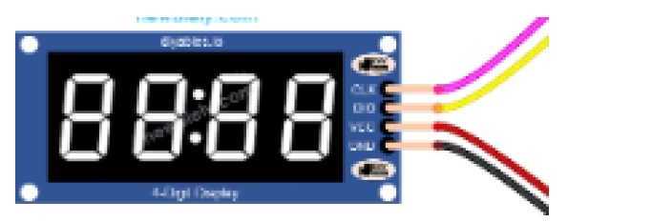

**Pins of seven segment display:**

* 1. CLK – Clock Pin
  2. DIO – Data Input Output Pin

These two pins are used to transfer the data.

* 1. VCC
  2. GND

These two pins are used to connect the power.

**Step2:** Connect these pins to GPIO pin of raspberry pi with the help of jumper wire.

**Connections are as follows:**

CLK Pin to 40th GPIO pin

DIO Pin to 38th GPIO pin

VCC Pin to 2nd GPIO pin

GND Pin to 6th GPIO Pin

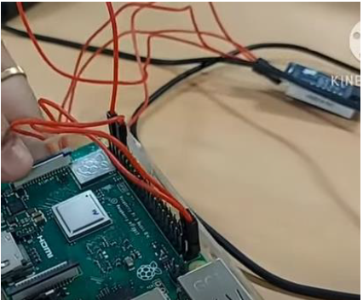

**Step3:** Download the file required to do operation from github desktop.

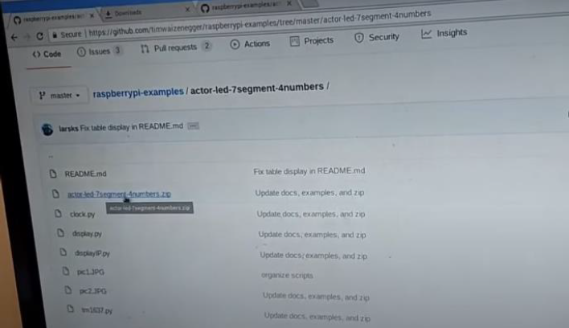

**Step 4:** In this folder use package “tm1637” to write the code.

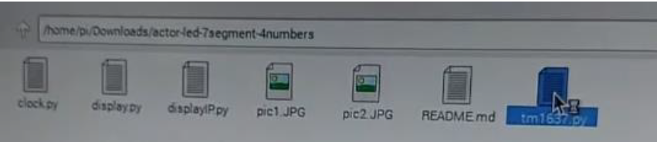

**Step 5:** Write the following Code.

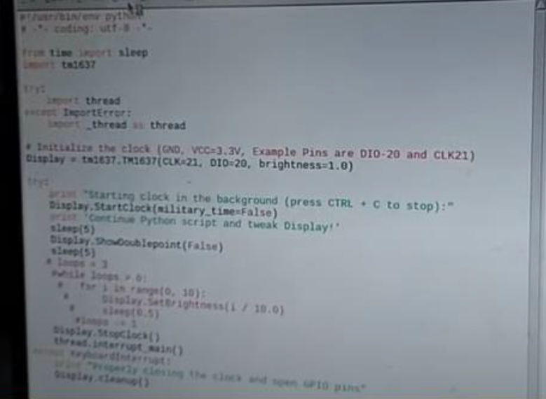

**Step 6:** Run the code the will display on seven segment display screen

